**Anti-Plagiarism Declaration**

This is to declare that the above publication produced under the:

**Title: PetBook**

is the sole contribution of the author(s) and no part hereof has been reproduced on **as it is** basis (cut and paste) which can be considered as **Plagiarism.** All referenced parts have been used to argue the idea and have been cited properly. I/We will be responsible and liable for any consequence if violation of this declaration is determined.

Date: 21-10-2022

Student 1

Name:

Student 2

Signature: Name:

Student 3

Signature: Name:

Signature:

Supervisor

Name:

Signature:

**Table of Contents**

1. Introduction 1

2. Vision Document 1

2.1. Problem Statement 1

2.2. Business Opportunity 1

2.3. Objectives 2

2.4. Scope 2

2.5. Constraints 2

2.6. Stakeholder and User Descriptions 2

2.6.1. Market Demographics 2

2.6.2. Stakeholder Summary 3

2.6.3. User Environment 3

2.6.4. Stakeholder Profiles 4

3. System Requirement Specification 6

3.1. System Features 6

*3.1.1.* *Login/Registration* 6

*3.1.2.* *Search items* 6

*3.1.3.* *Add to cart* 6

*3.1.4.* *Payment Integration* 6

*3.1.5.* *Live chat* 6

*3.1.6.* *Newsfeed* 6

*3.1.7.* *Ads posting* 6

*3.1.8.* *Pet authenticity* 6

*3.1.9.* *Hire trainers* 6

*3.1.10.* *Animal Photography* 6

*3.1.11.* *Pet adoption* 6

*3.1.12.* *Alerts* 6

*3.1.13.* *Rent a pet* 6

*3.1.14.* *Pet shows* 7

*3.1.15.* *NGO’s* 7

3.2. Functional Requirements 7

3.3. Non-Functional Requirements 7

4. Use case Diagram 8

5. High level Use case 8

5.1. Manage Users 8

5.2. Login/Signup 9

5.3. Send/Receive Messages 10

5.4. View News Feed 10

5.5. Receive Alerts 11

5.6. Post an Ad 11

5.7. View Pet Shows Info 12

5.8. Rent/Adopt a pet 13

5.9. Choose Payment Method 13

5.10. Contact NGO 14

5.11 Locate Nearby Pet Shops 14

5.12 Avail Services 15

5.13 Search Item 15

5.14 Authenticate Pet 16

5.15 Add to Cart 16

6. Expanded Use case 17

6.1. Login/Signup 17

6.2. Manage Users 18

6.3. Send/Receive Messages 20

6.4. Authenticate a pet 21

6.5. Search Item 22

6.6. Choose Payment Method 23

6.7. Post an AD 24

7. System Sequence Diagram 26

7.1. Login/Signup 26

7.2. Authenticate a Pet 26

27](#_Toc120600087)

7.4. Send/Receive Messages 27

7.5. Manage Users 28

8. Domain Model 28

9. Class diagram 30

1. Class diagram 31

2. Sequence Diagram 31

3. Data flow Diagram 33

4. ERD 34

34](#_Toc120600096)

**List of tables**

Table 1. Problem Statement 1

Table 2. Stakeholder Summary 3

Table 3. Supervisor of the Project 4

Table 4. Development Team of the Project 5

Table 5. US-1 Manage Users 9

Table 6. US-2 Login/Signup 9

Table 7. US-3 Send/Receive Messages 10

Table 8. US-4 View Feed 10

Table 9.US-5 Receive Alerts 11

Table 10. US-6 Post an Ad 12

Table 11.UC-07 View Pet Shows Info 12

Table 11.UC-08 Rent/Adopt a pet 13

Table 11.UC-09 Choose Payment Method 13

Table 11.UC-10 Contact NGO 14

Table 11.UC-11 Locate nearby Pet Shops 14

Table 11.UC-12 Avail Services 15

Table 11.UC-12 Search Item 15

Table 11.UC-14 Authenticate pet 16

Table 11.UC-15 16

Table 12:Login Signup 17

Table 13. Manage Users 18

Table 14: Send/Receive Messages 20

Table 15:Authenticate Pet 21

Table 15:Search Item 22

Table 15:Choose Payment Method 23

Table 15:Post an Ad 24

**Table of Figures**

Figure 1. Use Case Diagram 8

Figure 2:SSD-Login/Signup 26

Figure 3.SSD- Authenticate a Pet 27

Figure 4.SSD- Search Item 28

# Introduction

Animals are one of the most common and important parts of daily life. With our system, people can engage and solve their daily life queries about their pets and other stray animals. So, our project is based on a community filled with pet enthusiasts.

# Vision Document

In this section, the project vision is discussed in detail.

## Problem Statement

Table 1. Problem Statement

|  |  |
| --- | --- |
| The Problem of | * Pet owners not having enough knowledge about how to take care of their pets. * Not having a proper platform for buying and selling pets, their products, and accessories. * Pet owners are not aware of the best-suited food and habitat for their pets. * Lack of apps platform for pet-related communities. |
| Affects | * Pets suffer because of the lack of education of pet owners. * A lot of time is wasted in looking for the desired pet, its products, and its accessories. |
| A successful solution would be | * An App that provides users the online help for pet-related queries. * An App that provides an e-commerce platform for buying/selling pets, their products, and accessories. * An App that enables pet-related businesses to register themselves. |

## Business Opportunity

An easy way to connect and gather animals and pet enthusiasts under a single platform. Pet Book enables pet lovers to share their pet-related queries with each other and avail the help of experts online. Pet Book also provides an amazing business opportunity for pet-related businesses as they can register their businesses. Pet lovers can also buy and list their pets for sale.

## Objectives

platform for pet enthusiasts to connect with each other.

A platform for pet lovers to ask queries regarding their pets from experts online.

A platform for pet enthusiasts to buy/sell pets, their products, and accessories.

An opportunity for pet-related businesses to expand their businesses by registering their business on our platform.

## Scope

Pet Book is a mobile application. The main problem we are currently facing is pet lovers have no proper single platform to interact with each other. The other problem we are facing right now is that there is no proper platform for pet-related businesses where they can register their businesses online and connect them with a pet-related community. Pet Book will provide an environment through which all these entities would be able to build strong connections with each other.

## Constraints

If the amount of memory available in the phone is low, the system may ask your application to shut down or sacrifice cached data, slowing program execution.

The system shall not require any special hardware development or procurement.

If there is an internet problem, then app contents will not be loaded.

If the user is not registered, he cannot view the app contents.

If the pet-related businesses have not registered their business, then they will not be able to list anything for sale.

## Stakeholder and User Descriptions

Stake holders and user descriptions are defined below:

### Market Demographics

Our target market is any pet or animal-related entity (pet owners, businessmen, vets, pet trainers). Also, those people want to learn about animals and develop their interest in them.

### Stakeholder Summary

Table 2. Stakeholder Summary

|  |  |  |
| --- | --- | --- |
| **Name** | **Description** | **Responsibilities** |
| FAST-CFD | Have copyrights of our Final Year Project. | Provide resources and help to develop this application. |
| Supervisor and Co-supervisor | Involves Supervisor and Co-supervisor who are guiding the developers’ team while designing and implementing the project. | Monitors the project’s progress and helps the development team to develop the project. |
| Pet Book developers | Includes the development team involved in designing and implementing the application. | Design the application considering the user’s needs and should perform proper testing. |
| End-User | Includes pet owners, businessmen, vets, pet trainers, and people with some interest in animals. | Should have a basic knowledge of using smartphones. |

### User Environment

It is a mobile application that allows any user to install and use it. Users must have a basic knowledge of installing and using mobile apps. The proper user interface and installation guidelines must be sufficient to educate the users on how to use the application. It is an android application so it must operate on android phones.

### Stakeholder Profiles

The Stakeholder Profiles Attributes of the system are listed in this section.

#### **Supervisors of the Project**

Table 3. Supervisor of the Project

|  |  |
| --- | --- |
| Representatives | Supervisor: Mr. Usman Ghous  Co-supervisor: Dr. Umar Aftab |
| Description | They are involved in supervising the activities of the development process. |
| Type | They are technical stakeholders. They have expertise in domains that are being applied to this project. |
| Responsibilities | Monitors the project’s progress and helps the development team to develop the project within specified resources and time. |
| Success Criteria | The completion of features that are being committed by the development team at the start of the project. |
| Involvement | Requirement reviewer and review implementation. |

#### **Development Team of the Project**

Table 4. Development Team of the Project

|  |  |
| --- | --- |
| Representatives | Mr. Danish Ahmad  Mr. Muhammad Zain  Mr. Muhammad Umar |
| Description | Includes the development team involved in designing and implementing the application. |
| Type | They are technical stakeholders who build the project. |
| Responsibilities | Design the application considering the user’s needs and should perform proper testing. |
| Success Criteria | The completion of features that are being committed by the development team at the start of the project. |
| Involvement | Designers and Testers. |
| Deliverables | * Documentation * Development |

# System Requirement Specification

In this section, features and requirements of the system are explained.

## System Features

## *Login/Registration*

User must be able to login in the system.

## *Search items*

User will be able to search the desired items through the app.

## *Add to cart*

User will be able to add to - cart the items he/she wanted to buy.

## *Payment Integration*

User will get option for the payment, either an online payment or cash on delivery.

## *Live chat*

User will be able to do live chat with other users or with experts.

## *Newsfeed*

Newsfeed section will update the user about so many information and will develop the interest of the new users among the community.

## *Ads posting*

User will be able to post ads and queries.

## *Pet authenticity*

User will be able to check pet authenticity before making a purchase.

## *Hire trainers*

User will be able to hire trainers for the better development of their pets.

## *Animal Photography*

This module will provide user amazing photographs of animals and allow them to hire animal photographers.

## *Pet adoption*

Animal shelters will provide the healthy stray animals or left-out animals for adoption to the users.

## *Alerts*

It will be a sensitive feature and user will be able to filter out the alerts of their desired alerts.

## *Rent a pet*

User will be able to rent pets from other users for their functions or events.

## *Pet shows*

User will be able to get details about pet shows happening in near future.

.

## *NGO’s*

User will be able to contact NGO’s for animal related emergencies.

## Functional Requirements

The functional requirements of the system are listed below:

* User must be able to login in the system.
* User will be able to search the desired items through the app.
* User will be able to add to cart the items he/she wanted to buy.
* User will get option for the payment, either an online payment or cash on delivery.
* User will be able to do live chat with other users or with experts.
* Newsfeed section will update the user about so much information and develop the interest of the new users in the community.
* User will be able to hire trainers for the better development of their pets.
* Animal shelters will provide the healthy stray animals or left-out animals for adoption to the users.
* User will be able to locate nearby pet shops.
* Alerts will be a sensitive feature and user will be able to filter out the alerts of their desired alerts
* User will be able to rent pets from other users for their functions or events.
* User will be able to get details about pet shows happening in near future.
* User will be able to contact NGO’s for animal related emergencies.

## Non-Functional Requirements

* + Ensure a system that will keep the privacy of users.
  + To enhance the user experience, the system will be optimized and will tackle every kind of technical difficulties.
  + System will be functional 24/7. Down times will be notified earlier.
  + System will be secure to avoid any payment scams.
  + Data will be stored in secured database to avoid any misleading or misuse of data.
  + Only a quality content will be provided to users.

# Use case Diagram

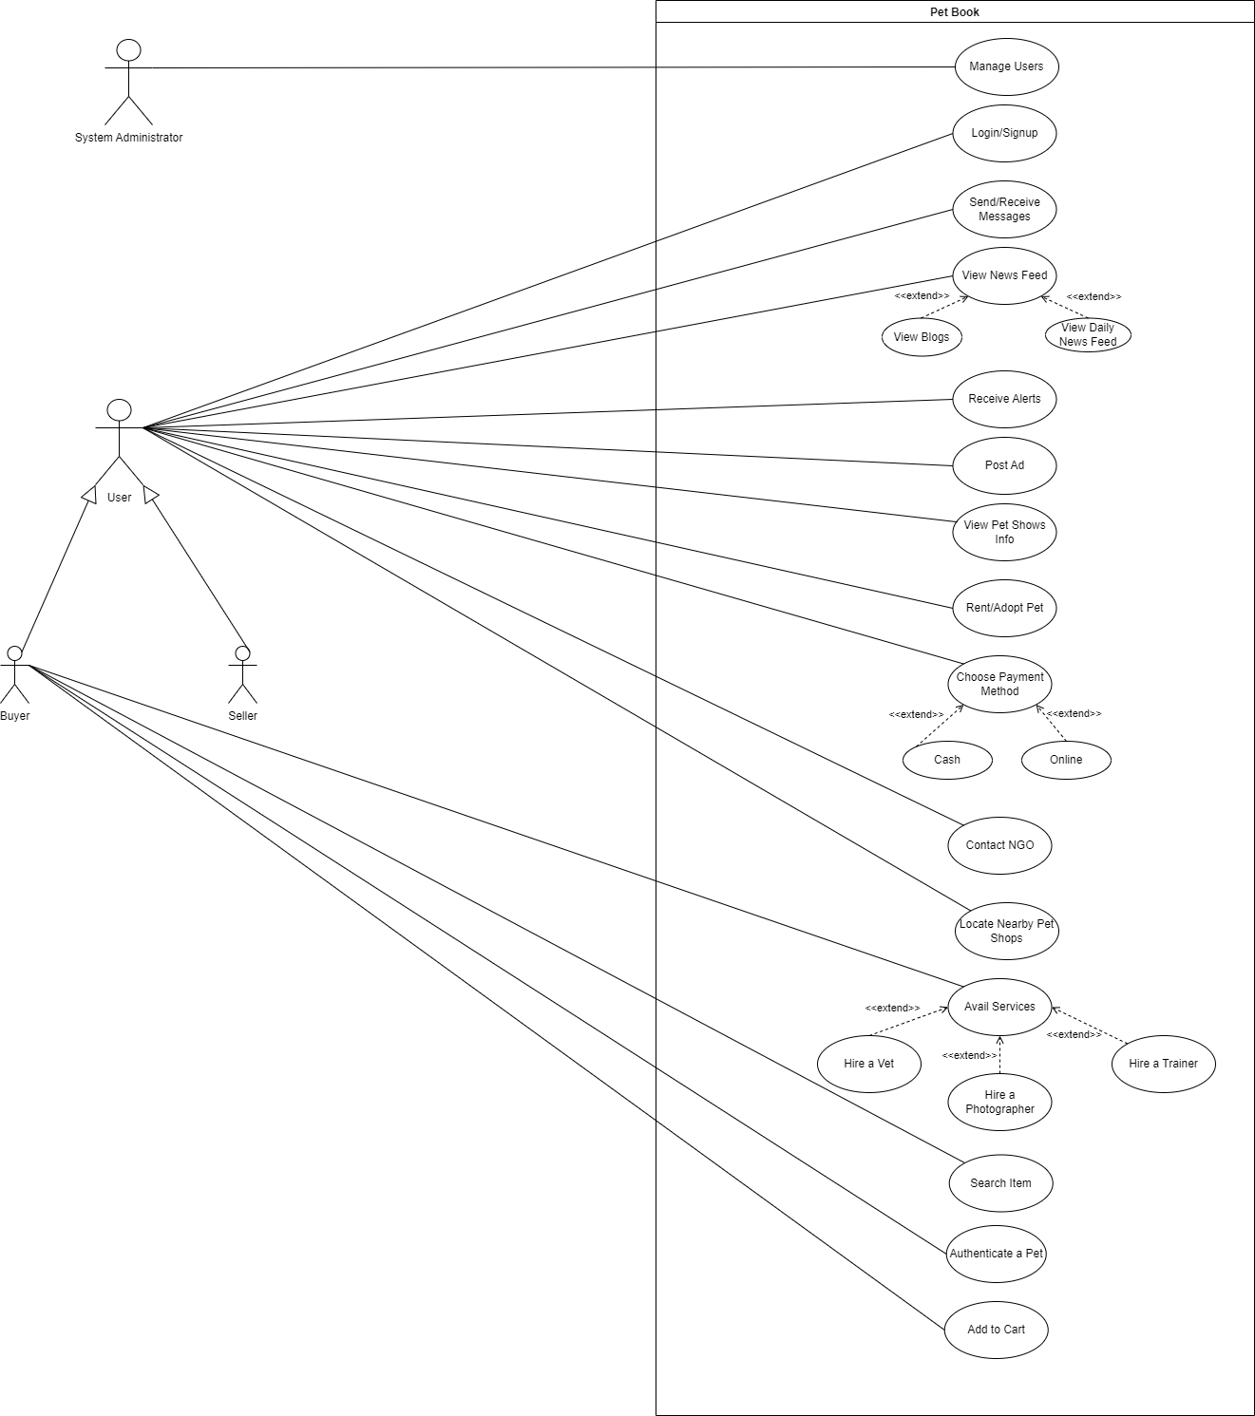

Figure 1. Use Case Diagram

# High level Use case

## Manage Users

Table 5. US-1 Manage Users

|  |  |
| --- | --- |
| **Use case ID** | 01 |
| **Use case Name** | Manage Users |
| **Actor** | System Administrator |
| **Type** | Primary |
| **Description** | The System Administrator manages the accounts of users. |

## 5.2. Login/Signup

Table 6. US-2 Login/Signup

|  |  |
| --- | --- |
| **Use case ID** | 02 |
| **Use case Name** | Login/Signup |
| **Actor** | Buyer, Seller |
| **Type** | Primary |
| **Description** | The Buyer/Seller would have to login into the system to continue using the application |

## 5.3. Send/Receive Messages

Table 7. US-3 Send/Receive Messages

|  |  |
| --- | --- |
| **Use case ID** | 03 |
| **Use case Name** | Send/Receive Messages |
| **Actor** | Buyer, Seller |
| **Type** | Primary |
| **Description** | The Buyer/Seller would be able to chat with each other. |

## 5.4. View News Feed

Table 8. US-4 View Feed

|  |  |
| --- | --- |
| **Use case ID** | 04 |
| **Use case Name** | View News Feed |
| **Actor** | Buyer, Seller |
| **Type** | Primary |
| **Description** | The user would be able to view the different posts on his news feed. |

## 

## 5.5. Receive Alerts

Table 9.US-5 Receive Alerts

|  |  |
| --- | --- |
| **Use case ID** | 05 |
| **Use case Name** | Receive Alerts |
| **Actor** | Buyer, Seller, System Administrator |
| **Type** | Primary |
| **Description** | The user will receive Alerts for awareness purposes. |

## 5.6. Post an Ad

Table 10. US-6 Post an Ad

|  |  |
| --- | --- |
| **Use case ID** | 06 |
| **Use case Name** | Search items |
| **Actor** | Customer |
| **Type** | Primary |
| **Description** | Customers would be able to search for  their desired item on the system. |

## 

## 5.7. View Pet Shows Info

## 

Table 11.UC-07 View Pet Shows Info

|  |  |
| --- | --- |
| **Use case ID** | 07 |
| **Use case Name** | View Pet Shows Info |
| **Actor** | Buyer, Seller |
| **Type** | Primary |
| **Description** | The user will be able to check info on ongoing pet shows and also can organize his own pet show and post in this section. |

## 5.8. Rent/Adopt a pet

## 

Table 11.UC-08 Rent/Adopt a pet

|  |  |
| --- | --- |
| **Use case ID** | 07 |
| **Use case Name** | View Pet Shows Info |
| **Actor** | Buyer, Seller |
| **Type** | Primary |
| **Description** | The user will be able to check info on ongoing pet shows and also can organize his own pet show and post in this section. |

## 5.9. Choose Payment Method

## 

Table 11.UC-09 Choose Payment Method

|  |  |
| --- | --- |
| **Use case ID** | 09 |
| **Use case Name** | Choose Payment Method |
| **Actor** | Buyer, Seller |
| **Type** | Primary |
| **Description** | The Buyer/Seller would be able to make/receive their payments. |

## 5.10. Contact NGO

## 

Table 11.UC-10 Contact NGO

|  |  |
| --- | --- |
| **Use case ID** | 10 |
| **Use case Name** | Contact NGO |
| **Actor** | Buyer, Seller |
| **Type** | Primary |
| **Description** | The Buyer/Seller would be able to get in contact with different NGOs. |

## 5.11 Locate Nearby Pet Shops

## 

Table 11.UC-11 Locate nearby Pet Shops

|  |  |
| --- | --- |
| **Use case ID** | 11 |
| **Use case Name** | Nearby Pet Shops |
| **Actor** | Buyer, Seller |
| **Type** | Primary |
| **Description** | The user would be able to locate the nearby pet shops. |

## 5.12 Avail Services

## 

Table 11.UC-12 Avail Services

|  |  |
| --- | --- |
| **Use case ID** | 07 |
| **Use case Name** | View Pet Shows Info |
| **Actor** | Buyer, Seller |
| **Type** | Primary |
| **Description** | The user will be able to check info on ongoing pet shows and also can organize his own pet show and post in this section. |

## 5.13 Search Item

## 

Table 11.UC-12 Search Item

|  |  |
| --- | --- |
| **Use case ID** | 13 |
| **Use case Name** | Search Item |
| **Actor** | Buyer |
| **Type** | Primary |
| **Description** | The user would be able to search for different items. |

## 5.14 Authenticate Pet

## 

Table 11.UC-14 Authenticate pet

|  |  |
| --- | --- |
| **Use case ID** | 14 |
| **Use case Name** | Authenticate a Pet |
| **Actor** | Buyer |
| **Type** | Primary |
| **Description** | The Buyer would check the authenticity of the pet he is going to buy. |

## 5.15 Add to Cart

## 

Table 11.UC-15

|  |  |
| --- | --- |
| **Use case ID** | 15 |
| **Use case Name** | Add To Cart |
| **Actor** | Buyer |
| **Type** | Primary |
| **Description** | The user would be able to add different items to his cart that he intends to buy. |

## Expanded Use case

## Login/Signup

## 

Table 12:Login Signup

|  |  |
| --- | --- |
| **Use case ID** | 02 |
| **Use case Name** | Login/Signup |
| **Actor** | Buyer, Seller |
| **Description** | The user would have to login into the system to continue using the application. |
| **Pre-Condition** | The user has installed the application |
| **Post Condition** | The user has logged in |
| **Normal Flow** | • Enter Username and password |
| **Alternative Flow** | • Authentication problem, request reset password  • Re-enter username and password |
| **Special**  **Requirement** | Availability of Internet |
| **Frequency of Use** | High |
| **Assumption** | The user knows how to login. |

## Manage Users

## 

Table 13. Manage Users

|  |  |
| --- | --- |
| **Use case ID** | 01 |
| **Use case Name** | Manage Users |
| **Actor** | System Administrator |
| **Description** | The System Administrator manages the accounts of users. |
| **Pre-Condition** | The system Administrator must be logged into the system. |
| **Post Condition** | The required changes must be made to the user accounts. |
| **Normal Flow** | 1. System administrator opens the application and enters login credentials. 2. System validates the credentials. 3. System grants access to the system administrator. 4. System administrator manages the account of the user when needed. 5. System saves the changes and returns a success message. |
| **Alternative Flow** | * The System administrator enters the login credentials.   • Login Credentials are incorrect.   * Error message is returned. |
| **Special**  **Requirement** | Availability of Internet |
| **Frequency of Use** | Normal |
| **Assumption** | The user intends to view other user’s profile to see their personal information |

## 

## Send/Receive Messages

## 

Table 14: Send/Receive Messages

|  |  |
| --- | --- |
| **Use case ID** | 03 |
| **Use case Name** | Send/Receive Messages |
| **Actor** | Buyer, Seller |
| **Description** | The user would be able to communicate with each other by sending or receiving messages |
| **Pre-Condition** | The user must be logged in |
| **Post Condition** | A message would be sent, or old messages would be viewed |
| **Normal Flow** | • Click on the option of Messages  • Send a message to someone  • View Received replies |
| **Alternative Flow** | • Message can not be sent due to an internet problem  • Refresh and try again |
| **Special**  **Requirement** | Availability of Internet |
| **Frequency of Use** | Normal |
| **Assumption** | The user wants to send a message or view a received reply from any other user |

## Authenticate a pet

Table 15:Authenticate Pet

|  |  |
| --- | --- |
| **Use case ID** | **04** |
| Use case Name | Search items |
| Actor | Customers |
| Type | Primary |
| Description | Customer search for the particular item on the system. |
| Pre-condition | Customer must be logged in. |
| Normal Flow | 1. Customer searches for the product. 2. System looks for the product if it is available on any store. 3. Results from various stores is displayed and use case ends with success. |
| Post-condition | Products result is displayed. |
| Alternative flow | * System checks if no result is available. * It displays no result is found |

## Search Item

Table 15:Search Item

|  |  |
| --- | --- |
| **Use case ID** | 14 |
| **Use case Name** | Search Item |
| **Actor** | Buyer, Seller |
| **Description** | The user would be able to search for different items. |
| **Pre-Condition** | The Buyer must be logged in. |
| **Post Condition** | The buyer will be shown the desired search result if the items exist. |
| **Normal Flow** | • Buyer searches for an item.  • System gets the searched item from the database. |
| **Alternative Flow** | • System could not find the searched item from the database. |
| **Special**  **Requirement** | Availability of Internet |
| **Frequency of Use** | High |
| **Assumption** | The system has all the data relevant to the search. |

## Choose Payment Method

Table 15:Choose Payment Method

|  |  |
| --- | --- |
| **Use case ID** | 09 |
| **Use case Name** | Choose Payment Method |
| **Actor** | Buyer |
| **Description** | The user would be able to make his payments. |
| **Pre-Condition** | There must be some items in the cart. |
| **Post Condition** | The buyer successfully made his payments. |
| **Normal Flow** | • Buyer checks out.  • Buyer enters billing details.  • Buyer enters shipping details.  • Buyer confirms the order.  • Use case ends with a success. |
| **Alternative Flow** | • Not enough amount in the bank. |
| **Special**  **Requirement** | Availability of Internet |
| **Frequency of Use** | Normal |
| **Assumption** | The user must have a bank account. |

## Post an AD

Table 15:Post an Ad

|  |  |
| --- | --- |
| **Use case ID** | 06 |
| **Use case Name** | Post an Ad |
| **Actor** | Buyer, Seller |
| **Description** | The user can post ads about anything related to pets. |
| **Pre-Condition** | The user must be logged in. |
| **Post Condition** | A request to post an Ad would be sent to the admin. |
| **Normal Flow** | • Click on the button to post an Ad.  • Enter related information and skillset required for the job  • Request would be sent to the admin to post a job |
| **Alternative Flow** | • Request can not be sent due to an internet problem or the request has been declined by the admin.  • Refresh and try again |
| **Special**  **Requirement** | Availability of Internet. |
| **Frequency of Use** | High |
| **Assumption** | The user wants to post an Ad for other users to view. |

# System Sequence Diagram

## Login/Signup

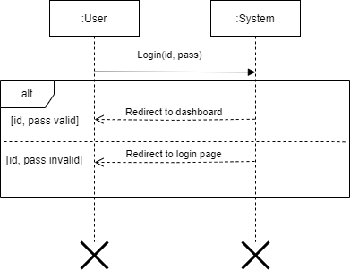

Figure 2:SSD-Login/Signup

## Authenticate a Pet

Figure 3.SSD- Authenticate a Pet

Figure 5.SSD- Choose Payment Method

## Send/Receive Messages

Figure 6.SSD- Send/Receive Messages

## Manage Users

Figure 7.SSD- Manage Users

# Domain Model

Figure 8. Domain Model

# Class diagram

Figure 9. Class Diagram

# Class diagram

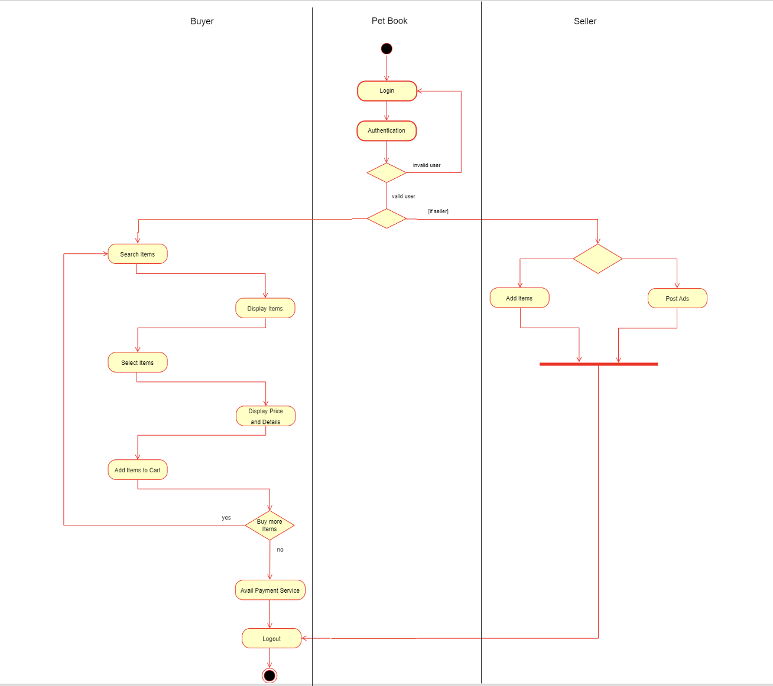

Figure 10. Activity Diagram

# Sequence Diagram

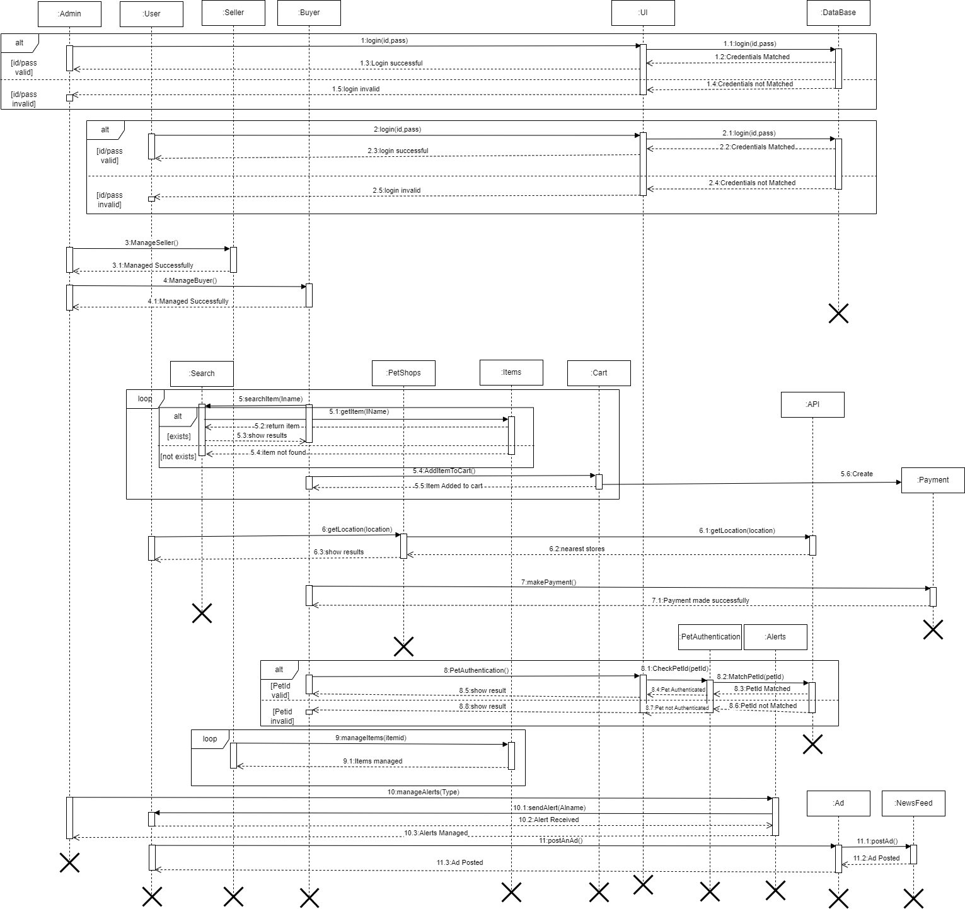

Figure 11. Sequence Diagram

# Data flow Diagram

Figure 12. Data Flow Diagram

# ERD

Figure 13. ERD